


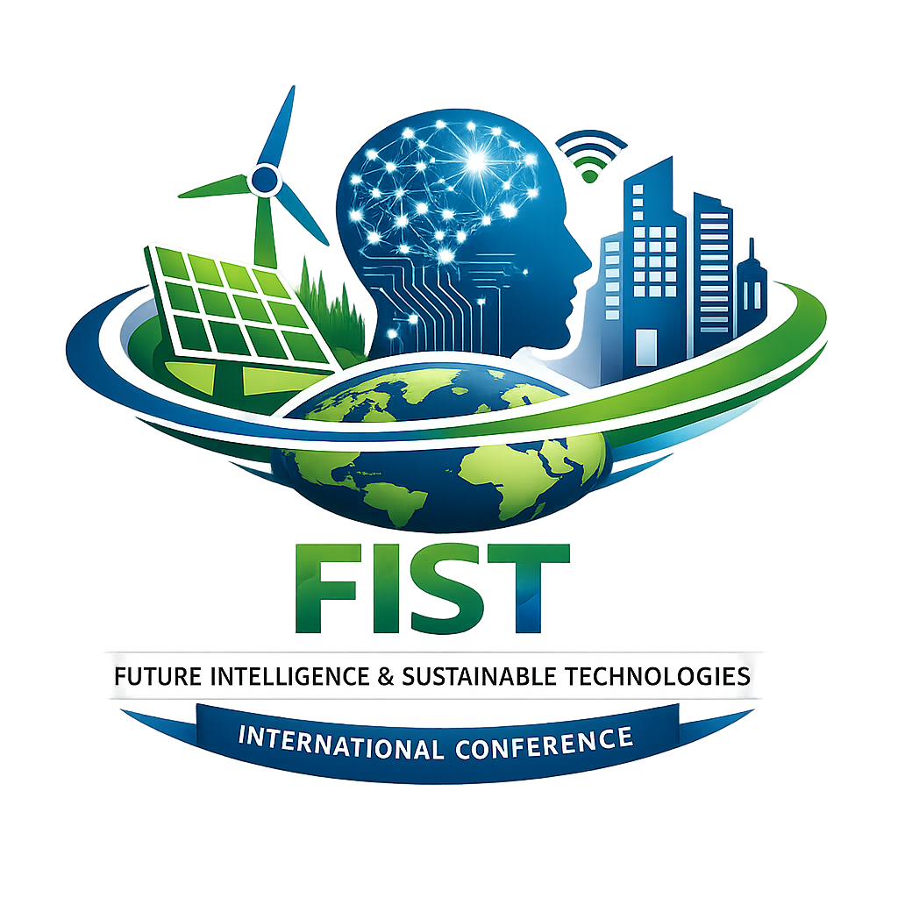

FIST-2027
International Conference on Future Intelligence and Sustainable Technologies
ORGANISED BY: Bhagwan Parshuram Institute of Technology, Rohini, New Delhi, India

27-28thAugust, 2027

************** CALL FOR PAPERS ***************

SPECIAL SESSION ON
[Insert Special Session Title]

SESSION ORGANIZERS
[Name, Affiliation with logo, Country]
Email: [Email ID]
(Multiple organizers may be listed)

EDITORIAL BOARD (Optional)
[Name, Affiliation, Country]
Email: [Email ID]

SESSION DESCRIPTION
[Provide a clear and concise description of the special session. The description should outline the motivation, objectives, relevance to the conference theme, and the type of research contributions expected. Typically, 120–150 words are sufficient.]

RECOMMENDED TOPICS
Topics of interest for this special session include, but are not limited to:
• [Topic 1]
• [Topic 2]
• [Topic 3]
• [Topic 4]
• [Topic 5]
• [Additional related topics, if any]

SUBMISSION PROCEDURE
Researchers, academicians, and industry practitioners are invited to submit original research papers to this special session on [Insert Session Title] on or before 31 January 2027.
All submissions must be original and should not be under review or published elsewhere. Papers must be prepared and submitted in accordance with the conference manuscript submission guidelines available at:
https://fistconference.com/paper-submission
All submitted papers will undergo a double-blind peer review process.

IMPORTANT NOTE
While submitting the manuscript, authors must clearly mention the Special Session Title at the top of the first page of the paper (above the paper title) to ensure correct consideration under this special session.

